The Antiochian Basilica of St. Mary
18100 Merriman Rd. Livonia, MI 48152 (734) 422-0010

ARABIC SCHOOL
We are pleased to announce that the 20-week session of
St. Mary’s Arabic School will be starting on
October 6th, 2019 until March 29th, 2020.
Classes meet every Sunday from 12:30 to 1:30.
We accept students ages 4 - 18.

Registration will be on September 22 & 29, 2019
from 12:00 to 1:00 at the activity center.
contact: Lina Nunu Matta - (313) 516-9986.

$50/Student 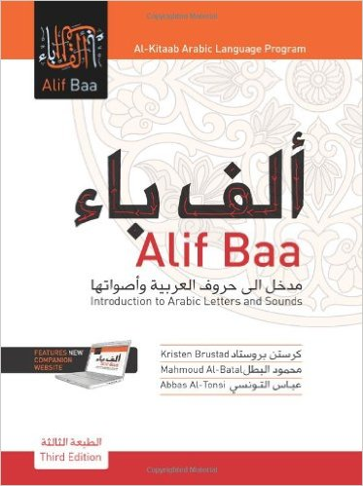
October 6
October 13
October 20
October 27

November 3
November 10
November 17 X
November 24

February 2
February 9 X
February 16
February 23

March 1
March 8
March 15
March 22
March 29

December 1 X
December 8
December 15 X
December 22 X
December 29 X

January 5
January 12
January 19
January 26

X– No Arabic School

Student’s Name Birthday Grade

1) ________________________________________ / / _______

2) ________________________________________ / / _______

Parents’ Name: ______________________________________

Phone Number: ______________________________________

